Student’s name | …………………………………………………….…… | Grade | 7
Subject | Computer | Week No. | 12
Lesson Title | Electronic Devices and Sensors | Unit
Worksheet No. ( 12 ) (Answer)

Question A: write the correct name of each part.
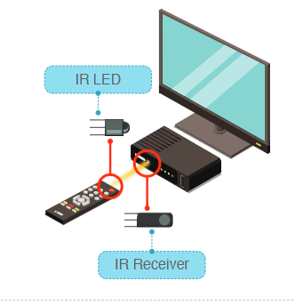
IR LED | IR Receiver

Good Luck

